|  |  |  |  |  |
| --- | --- | --- | --- | --- |
| NUS High School of Mathematics and Science |  | p. 8143 8417 |  | sudharshan@makerforce.io  sentibots.makerforce.io |

Frugal drone platform for educational purposes

September 10, 2016

S

Table of Contents

1. Abstract 2
2. Introduction and current problems 3
3. Hardware Design 4
4. Electronics Design 7
5. Software Design 9
6. Results 10
7. Conclusion 10
8. References 11

# Abstract

Consumers were asked to participate in an anonymous survey to help the company’s customer service department evaluate the effectiveness of their services. The survey included questions about the client’s most recent experience. It asked questions about their interaction with staff, staff response times; and whether the client’s issue was resolved. The survey also asked respondents to give an overall summary of their experience. A total of [325] responses were received from a total of [1000] surveys mailed to customers.

Items on the survey were worded as positive statements or direct questions, and included the following topics:

* Overall communication response time
* The customer service representative’s level of knowledge
* Professional characteristics of the customer service representative
* Whether the problem had been resolved

**Note**: The complete survey questionnaire is included later in this document for reference.

# Introduction and current problems

“I flew our shiny new drone up through the umbrellas on the quad, up past the roof of the gym, and into the low scattered clouds. The camera projected back to my iPhone, and I could see my school site in a totally different way. I saw the newly planted trees in our quad, the only green for miles in the Mondrian-like concrete grid that is our local community.

The students were in class, and the few teachers during their preparation period all peered up, shielding their eyes to see it fly. The custodian pulled up with his cart, and my assistant principal whooped like one of the middle school students on my campus.

I saw the drone hover about 60 feet off the ground, and it made me smile at the possibilities it represented. The people around me stood nodding, lost in the dreams I had shared.

And then it crashed.

The damn drone fell like a stone from the sky. The other teachers scattered, and the custodial cart left a trail of dust in its wake. They had all abandoned me to the broken pieces of plastic hull and crushed curricular dreams.”[1]

This is not just a made up story. It is a real occurrence with a teacher who hoped to bring drones to schools as platform to conduct learning. H envisioned using it in **social studies, language arts, P.E, Math, Science and community building**. However, his visions were never brought to life. [1]

## The solution

Given the problem above, we can see that commercial drones are simply not viable for use in education. Before we try and come up with a competitive solution, we have to analyze the commercial drone platforms and figure out the problems with the platforms.

The first obvious issue is the safety. With the most common drone platforms being the AR Drone from Parrot and the Phantom lineup from DJI, we can see a common trend of exposed propellers. Given that schools are responsible for the lives of their students, it is not surprising that schools are unwilling to take the risks involved in using these platforms to engage the students in schools. Another observable trend would be that they are all very big and generally speaking big drones are more dangerous that smaller ones. This adds more to the safety issue at hand.

The second concern would be the cost as the schools will have to purchase quite a few drones to cater to that many students and with prices of 500 dollars and above for commercial drones, bringing drones to the students is simply not economical for many schools and institutions.

The last concern would be the ease of use. Drones like the Parrot AR Drone and the Phantom lineup are at the heart marketed for commercial/aerial photography purposes and do not come with the features that would be worthwhile for students. This means that it is quite hard to hack and modify these drones to give a hands on experience for these students. The software and the hardware needs to be designed to be extremely hackable and easy to use for drones to enter into the educational market.

Thus, we present our solution, **SentiBots.** **SentiBots** is a custom design robot designed primarily with education in mind. It incorporates a low cost, highly safe platform with APIs and support software to provide an all in one package for educational institutions. The **SentiBot** platform uses a novel frame design to combat the safety and ease of use issues which makes it attractive for research institutions. It uses reduction in complexity to allow for a drop in cost as compared to quadcopters.

# Hardware Design

## Analyzing the needs for a good educational drone

Looking at what we discussed above, it could be said that the safety of a drone is quite essential for a good educational drone as it ensures the safety of its end users and it reduces the risk incurred by the school when they adopt drone makes curriculums to engage the children.

Another important factor that we discussed would be the cost and the price of the drone will heavily influence the adoption rate of the drone by schools simply due to the factor of economics.

Lastly, we discussed about how ease of use and hackability will play a key part in market adoption of a educational drone as the students must be able to be hands on and hack and modify the drone with ease.

In conclusion the good features and needs for an educational drone would be safety, cost and ease of use. Clearly, conventional drones which take the quadcopter approach don’t fit the bill as they are considered quite expensive, hard to hack and modify and quite unsafe for use in schools.

## Flight frame design

The novel frame design of the SentiBots platform is one of the key reasons for its ideal characteristics for education. The SentiBot uses what is called a dual-copter design which means that the thrust is provided by 2 counter rotating propellers enclosed in an EDF (Electronic Ducted Fan) form factor.

This allows for a heavy reduction in cost for the platform as the dual-copter design only uses 2 motors in contrast with the 4 motors in a conventional quadcopter based drone. This means that the dual-copter design only needs 2 motors and 2 ESCs (Electronic Speed Controllers) as compared to a quadcopter which needs 4 motors and ESCs. Since motors and ESCs are most of the cost in a quadcopter platform, a reduction in the number of motors results in a huge reduction in price which makes our platform a much easier pill to swallow in terms of financial investment.

The lowering in the number of moving parts also reduces the complexity and thus the chance of failure. By using a EDF based design, we also manage to get superior static thrust performance as compared to conventional quadcopters due to the reduction in vortices at the tip of the propeller. EDFs also increase the efficiency of the motors and allow for more thrust with the same amount of current drawn.

The counter rotating EDF also helps by negating the counter torque effects which come from using a single motor design such as the spherical flying vehicle. [2]

## Control System

For control, we went for 4 control surfaces much like a conventional coax-copter. These control surfaces work much rather in the same way as airplane flaps and direct air to achieve control. By enclosing the whole design in a cylindrical shaped frame, we enable the frame to contain all the essential electronics inside the frame and prevent damage to the moving components.

This frame also helps out with the safety issue as the enclosure protects students from accidentally hurting themselves by either touching the moving propellers or the moving components such as servos inside the frame. The frame also helps protect students from getting hit by anything sharp even if the drone is accidentally crashes into them.

## Flight measurements

By spinning counter-rotating bullnose propellers using a 4000kV race quad motor, we were able to achieve an incredible amount of thrust to space ratio. The total thrust comes around 800g as compared to a similar sized quad in terms total propeller surface area which might have a thrust of 50g.

This is because 4 smaller propellers occupying the same amount of space as 1 big propeller is more inefficient as bigger propellers are considered to be more efficient than smaller propellers. The SentiBot platform is running a 16.8V lithium polymer battery and is currently the smallest platform of its kind today.

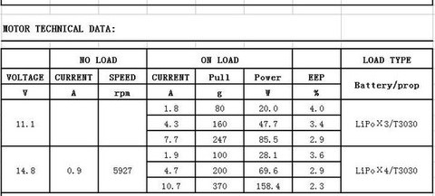This is important as smaller drones are safer than larger drones as if they impact humans, the lower momentum is less likely to cause damage. This also helps with the safety aspect of the SentiBot design. Our platform is also novel as drones that operate based on similar operating principles also are several orders of magnitude bigger due to the inability to offer this much thrust per unit space.

## Modularity

Using the cylindrical design as a reference point for the design, we added modularity by ensuring a complete bolt based design. The SentiBot can be easily accessed with just a hex driver. You can also easily get access to the main processing board by just removing the top cover, allowing students to easily access the electronics for experimentation.

This is again important to allow for the ease of use aspect for education. The ability to hack the hardware makes it useful hands on students who are willing to experiment with the drone platform to learn.

## Enhancing large scale manufacturing

Lastly, the frame design allows for easy large-scale manufacturing. The 3D files which make up the components in the frame are simple 3D shapes that can be easily molded and cast thus making it easier to manufacture for research purposes. As of now the frame uses a Poly-lactic acid (PLA) material, but this material could be changed to more durable ones like polycarbonate or Nylon-6. The 3D printable files can also be made open-source to make it more accessible for students.

In conclusion, the frame design allows for a durable and modular swarm platform which is able to be easily modified for experimentation by students.

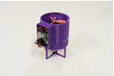 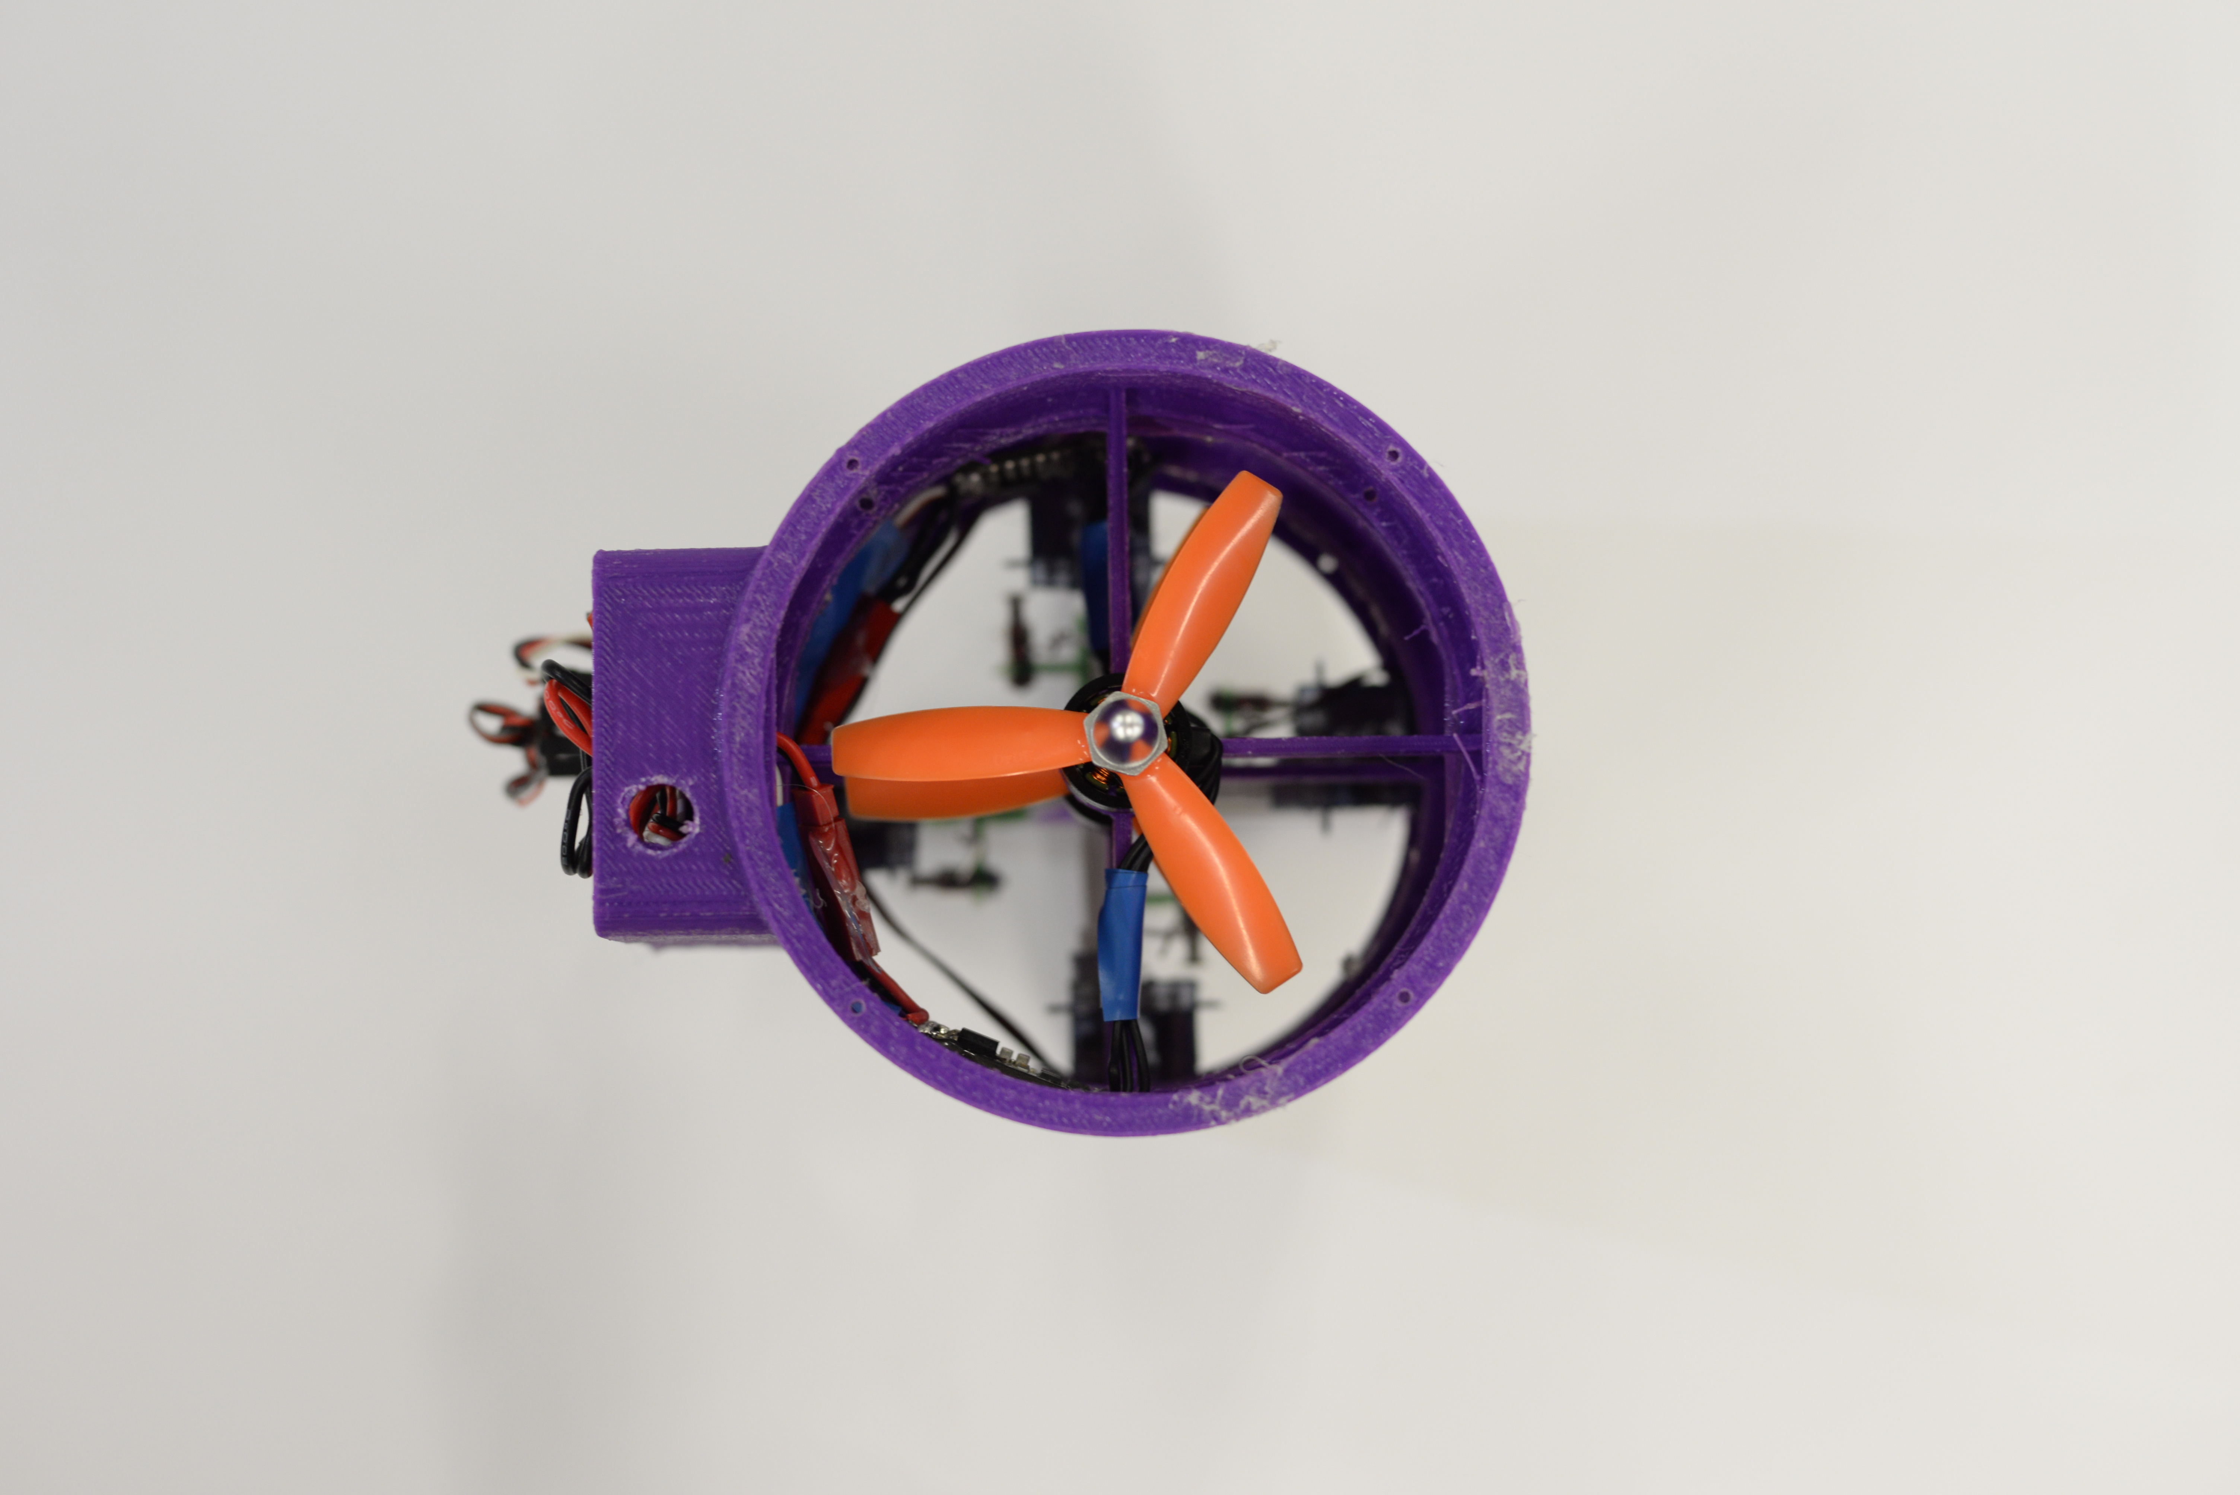

# Electronics Design

## Introduction

As important frame design is for an ideal educational platform, is the importance of electronics to the educational platform. The electronics of the SentiBots is considered the brain of the SentiBots and must have the capabilities to do from the simplest navigation to the complicated vision processing.

## Main Processor

For an educational platform, the students need to be able to do complicated vision processing tasks such Simultaneous Localization and Mapping (SLAM). This is because the educational drone platform is intended to cater to a range of students from secondary level to university level.

While secondary level students expect the ease of use and the simple capabilities, the university level students will need a higher level of hackability and processing power as they tackle more complicated issues in vision processing and advanced navigation.

This means that we need a powerful main processor to handle the extra stress from such algorithms. . Our processor of choice was the Intel Edison. It provides a decent amount of computing power operating at 500MHz with 512MB of RAM. It also has 4GB of onboard storage for any applications or programs. Since it runs a version of Debian Linux, Ubilinux, it makes it very easy for you to program it.

This architecture and software combination makes it easy to use for secondary students along with providing the hackability that the university students expect and need.

## ATMEGA 328 and lower level processing

We realized that we needed a separate microcontroller to manage the control logic to avoid too much pressure on the Edison. We ended up using the ATMEGA 328 microcontroller chip and flashing the control logic onto it. By using a ATMEGA 328, we also obtained additional sensor expandability options through getting more GPIO which could be used.

To combine the main processor with the lower level processor to get a dual CPU system, we designed a custom PCB which makes a very versatile control board for students to use. The separation of the higher and lower level processing also provide code organization in the software section as it allows for the higher and lower level code to be separated. T

This helps because the students can selectively experiment with the high level software and change code without affecting the lower level code which helps with debugging in case something goes wrong. This works in both direction where students can also edit the lower level code without affecting the higher level code.

## IMU (Inertial Measurement Unit)

The control loop also required an Inertial Measurement Unit (IMU) to detect orientation and compensate for oscillations present in the frame. By using an I2C interface to the ATMEGA 328, we managed to connect the MPU6050 and a barometer to the chip which allows for the chip to compensate for oscillations.

This will also help to stabilize the frame as seen in the following section. The MPU6050 is connected to the custom PCB through a set of header pins which allows the IMU to either be temporarily or permanently connected to the PCB.

## Flight Drive system specifications

The power electronics consists of 4 1C 1200mAh batteries, 2 30A super light ESC’s and 2 4000kV 1306 motors. The motor have a max current draw of 8A each and taking into consideration that the max thrust of each motor is 370g the gram per current rating for each motor is 46g/A.

Since the weight of the SentiBot is about 320g, the nominal current draw during a hover would be about 7A. That gives us a flight time of about 10-15min. This is a pretty respectable amount of flight time for a conventional drone. This configuration can of course be changed in case the user requires more power or more flight time.

## Power Supply management

Lastly, I would like to talk about the power management system in the SentiBot. We will be using the in-built BEC in the ESC which provides clean 5V out to power the board. The board also has an onboard 3V regulator to provide power to the Edison and the logic level converter which allows UART communication between the 1.8V Edison and the ATMEGA328 for the Edison to send high level commands to the ATMEGA 328 controller.

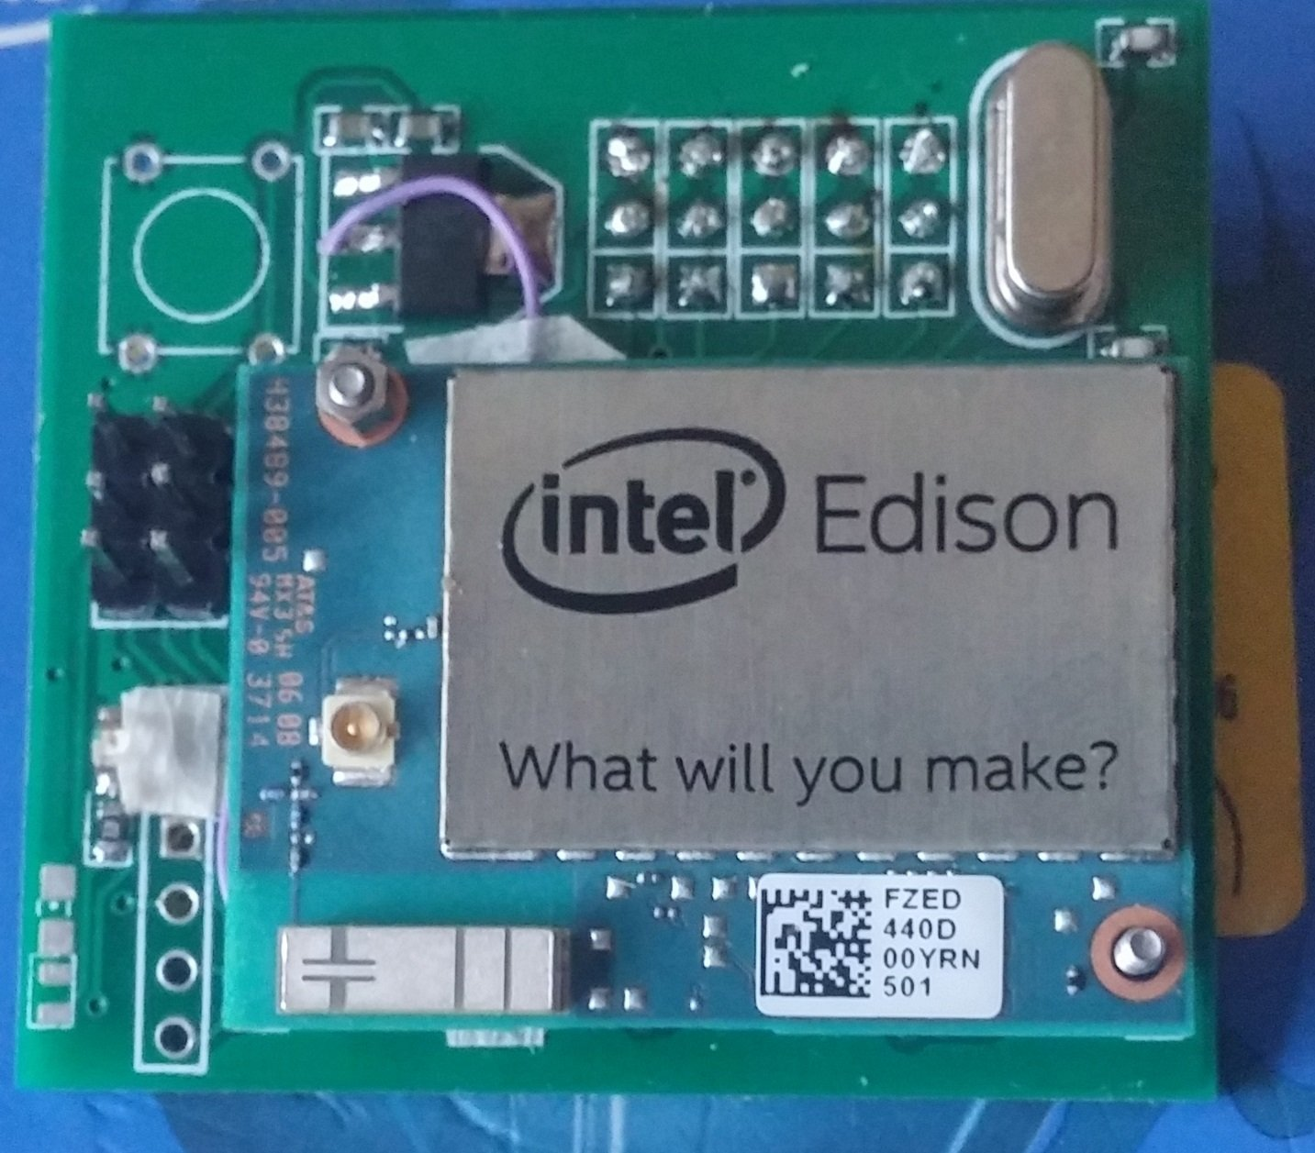 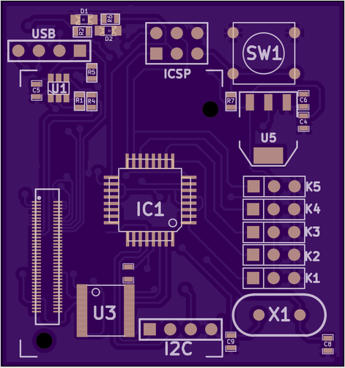

# Software Design

Although our research focuses on creating a hardware platform, it seemed to be irresponsible to neglect the software completely. This we have some up with some basic software for the students to have an easy experiencing developing and using this platform. We have also outlines some software design ideas for future project follow-ups.

## PID Loop

The control algorithm used in the SentiBot is similar to all the other control algorithms used in typical quadcopters. Implementing the classic PID control loop, we allow the sensor data to be mapped into error values that can be used to compensate for frame errors and instabilities in the frame.

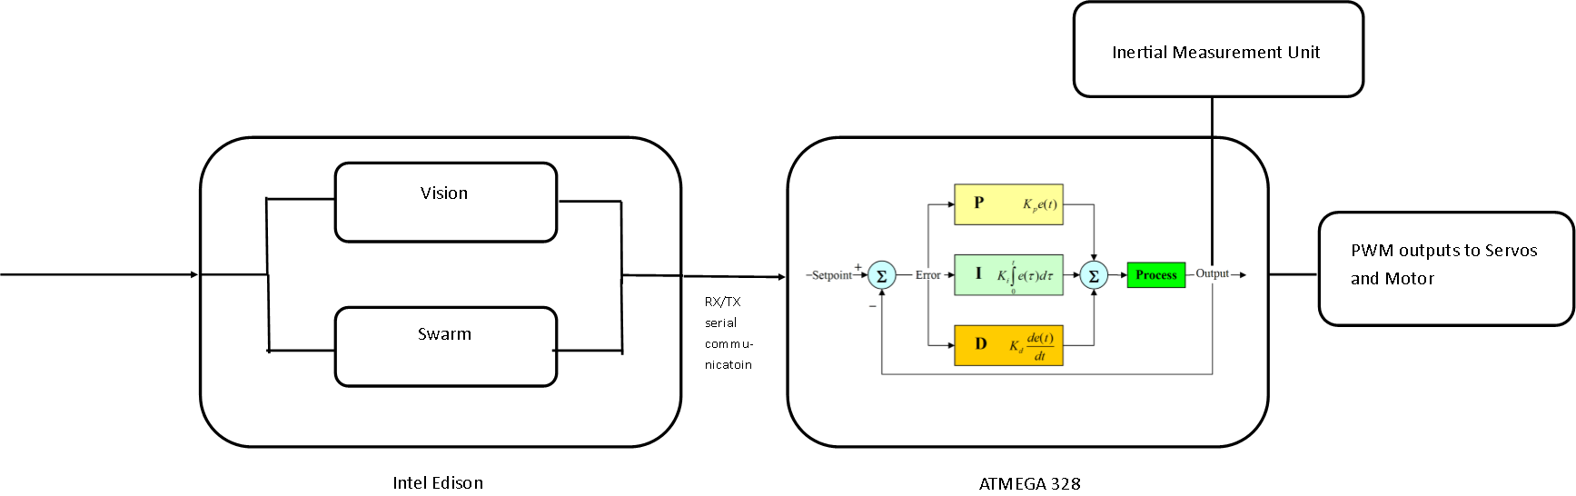The control algorithm first reads the I2C bus and outputs the data from the IMU which has been preprocessed by the Digital Signal Processor (DSP) on board the IMU. This allows for the control algorithm to get filtered and processed yaw-pitch-roll (**ypr**) data for use in the PID algorithm. The processed **ypr** values are sent through the respective PID loops for their specific axis and used to obtain 3 error values for each of the x, y and z axis. These error values can then be used to output to the servos, which then tries to bring the system back to the stable state by moving the specific servos. The barometer also enables altitude hold using another PID loop. All of the control algorithm runs onboard the ATMEGA 328.

## Android Application

The android application allows for us to take manual control of the SentiBot to conduct testing and provides a basic debug window amidst other features to make debugging easier. It is using a simple UDP interface and connects to the Edison via Wi-Fi which allows us to issue instructions to the SentiBot. Lately we have also added a Spektrum satellite receiver through the spare UART2 port to achieve 2.4 GHz radio control for longer range and lesser latency.

## Software stack

A future follow up for the software stack would be to craft an API to make it easy for students to experiment and use the platform. Along with that drag and drop programming tools, it could make it intuitive and easy to learn drone programming.

# Results

The results of initial testing were positive. The SentiBot shows the ability to lift off, and fly in a stable hover with minimal user intervention. When moved around, the SentiBot platform can accurately maintain its attitude without much user compensation. Currently, the SentiBot is manually controller but research is underway to demonstrate its autonomous functionality.

Furthermore, the drop tests were significantly positive showing that the SentiBot can survive drops from up to 3m high due to its rigid 3D printed PLA frame. I believe more time is needed to further test the SentiBots as well. That will be detailed in a later report. These drop tests were conducted through flying to robot up to a certain height and removing power from the motors and measuring how high we could drop from before there was damage to the frame. Only one test run was conducted.

In testing, the top speed achieved from the SentiBot is also about 20km/h and flight times are about 15 minutes with normal flying. This values are estimated from the given thrust and current draw information measured from ground tests. Furthermore, the SentiBot is should be able to achieve versatile flight through, under and over several obstacles without any problems due to its small size and form factor. The SentiBot can also easily take collisions with walls or other obstacles without falling due to its shell.

# Conclusion

The SentiBot project set out to bring an extremely safe, easy to use and cheap drone for use in educational institutions around the world. It aimed to solve some critical issues in bringing consumer drones to educational institutions for use in student interaction and learning processes by making an ideal drone platform that caters to the cost, ease of use and safety issues presented in those consumer drones.

We have created that platform in SentiBots. The competitive pricing with consumer drones while providing one the safest and most hackable drones in the world today makes it an awesome purchase for educational institutions ranging from secondary schools to tertiary institutions and universities.

In conclusion, this project has fulfilled all the requirements it set out to meet in the form of an education oriented consumer drone. We hope that this project accelerates the use of drones in education by increasing the adoption rate of these drones in the education market.

# References

[1]- <http://www.edutopia.org/blog/7-ways-use-drones-classroom-heather-wolpert-gawron>

[2]- OSU UAS. (2012). UFRO. Available: https://unmanned.okstate.edu/ufro Last accessed 29/12/2015.[2]- Miwa Suzuki. (2011). Japanese inventor develops flying sphere drone. Available: [http://phys.org/news/2011-08-japanese-inventor-sphere-drone.html. Last accessed 12/11/2015](http://phys.org/news/2011-08-japanese-inventor-sphere-drone.html.%20Last%20accessed%2012/11/2015).

[3]- OSU UAS. (2012). UFRO. Available: https://unmanned.okstate.edu/ufro Last accessed 29/12/2015.